Nowhere? Somewhere in Time <<時光倒流七十年>>
Have you guys heard a song named "Turn the Clock Back" <<時光倒流二十年>> by Cantopop megastar Eason Chan 陳奕迅? Actually, the lyrist Lin Xi 林夕 deliberately design the title of this song as a reference to the Chinese name of the film "Somewhere in Time" <<時光倒流七十年>>, and this film is a collective memory of earlier generation of Hong Konger. Previously, HK actor Ronald Cheng 鄭中基 played a role in a film named "Himalaya Singh" directed by Wai Ka-fai 韋家輝, and one of the parodic scene was made as an homage to "Somewhere in Time".
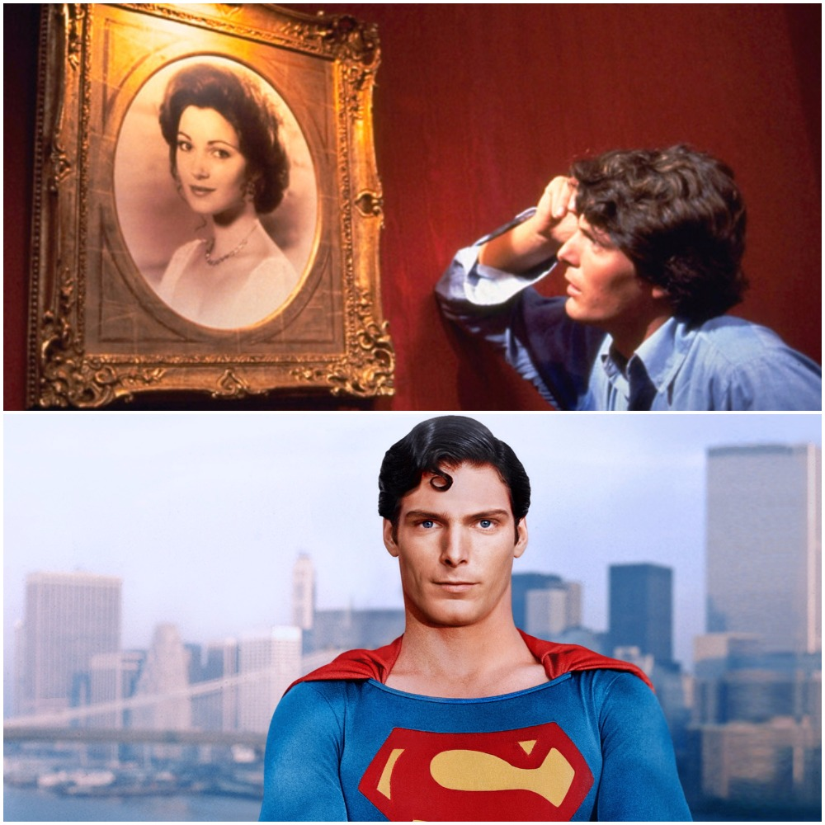
(Source: Google)

(Is the actor looks familiar to you? Guess what? He is the portrayer of Superman! His name is Christopher Reeve, and he acted as a sensitive, passionate lover in "Somewhere in Time"!)

Hey!! You can borrow "Somewhere in Time" from the PolyU library!! Go to the Multimedia Commons on the 3rd floor and find the film according to this call number!!

Editor: Jacky, Shea Kin Tung

Some Like It Hot 《熱情如火》

Envisage Monroe as a decent woman…Would she still be considered as a legend?
夢露若果 莊重高雅 何來絕世佳話
"The Tale of Helen of Troy" <<芳華絕代>>--Anita Mui 梅艷芳 & Leslie Cheung 張國榮

The abovementioned Cantopop song's lyrics has mentioned two famous sex symbols. One is Brigitte Bardot 碧姬芭鐸 and the other one is Marilyn Monroe 瑪麗蓮夢露. The success of Monroe's role in the film "Some Like It Hot", directed by Billy Wilder 比利·懷德 who is famous for his comedies and film noirs like "Double Indemnity"《雙重賠償》, further established her as a superstar in Hollywood.

Actually, Hong Kong comedians had made frequent attempts in adapting Wilder's works. For instance, Michael Hui 許冠文 has made an adaption called "Happy Ding Dong" <<歡樂叮噹>>. The story is basically borrowed from "Some Like It Hot", and the main difference is that he plays both the parts of Tony Curtis 托尼柯蒂斯 and Jack Lemmon 傑克李蒙. There is also another HK film named "Mr. Unfaithful" <<偷情先生>>, starring Cantopop singer Kenny Bee 鍾鎮濤 and the legendary lyrist James Wong 黃霑, and it is another adaption of Wilder's work "The Apartment" 《公寓春光》.
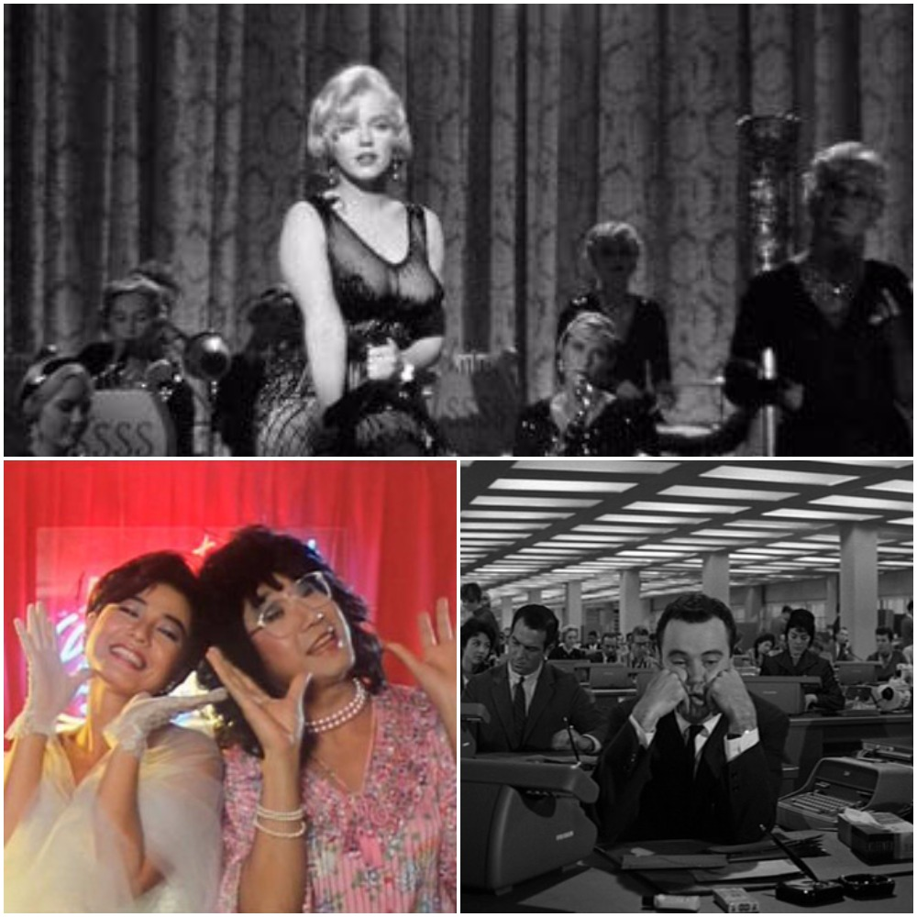
(Top: Some Like It Hot, Bottom Left Corner: Happy Ding Dong, Bottom Right Corner: The Apartment)
(Source: Google)

Hey!! You can borrow "Some Like It Hot" and "The Apartment" from the PolyU library!! Go to the Multimedia Commons on the 3rd floor and find the film according to the call numbers mentioned in the hyperlink!!

What about the other sex symbol Brigitte Bardot? We would talk about her next time.

Editor: Jacky, Shea Kin Tung

